

UNIVERSITY OF PETROLEUM & ENERGY STUDIES
Dehradun

CONTINOUS INTEGRATION
AND
CONTINOUS DELIVERY

Experiment

Name: Madhav Bhatia
Course: B. TECH CSE DevOps (2018-22)
Roll no.: R171218061
Sapid: 500068227

Experiment-3
Jenkins Integration with GitHub and Maven

Step-1: Open terminal and type the command to run the Jenkins.
“$ /etc/init.d/jenkins start”
Type localhost:8080 in the browser to run the Jenkins and login.ggggggg

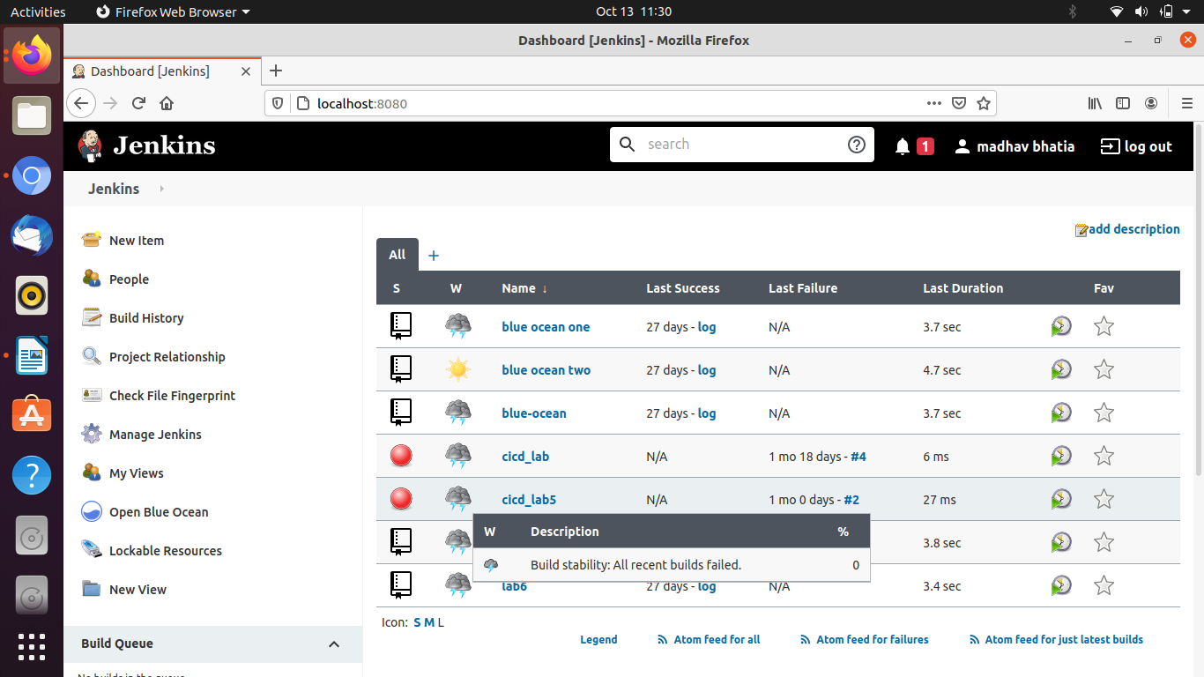

Step-2: Click on the new item to create a new maven project and specify the name and click ok.

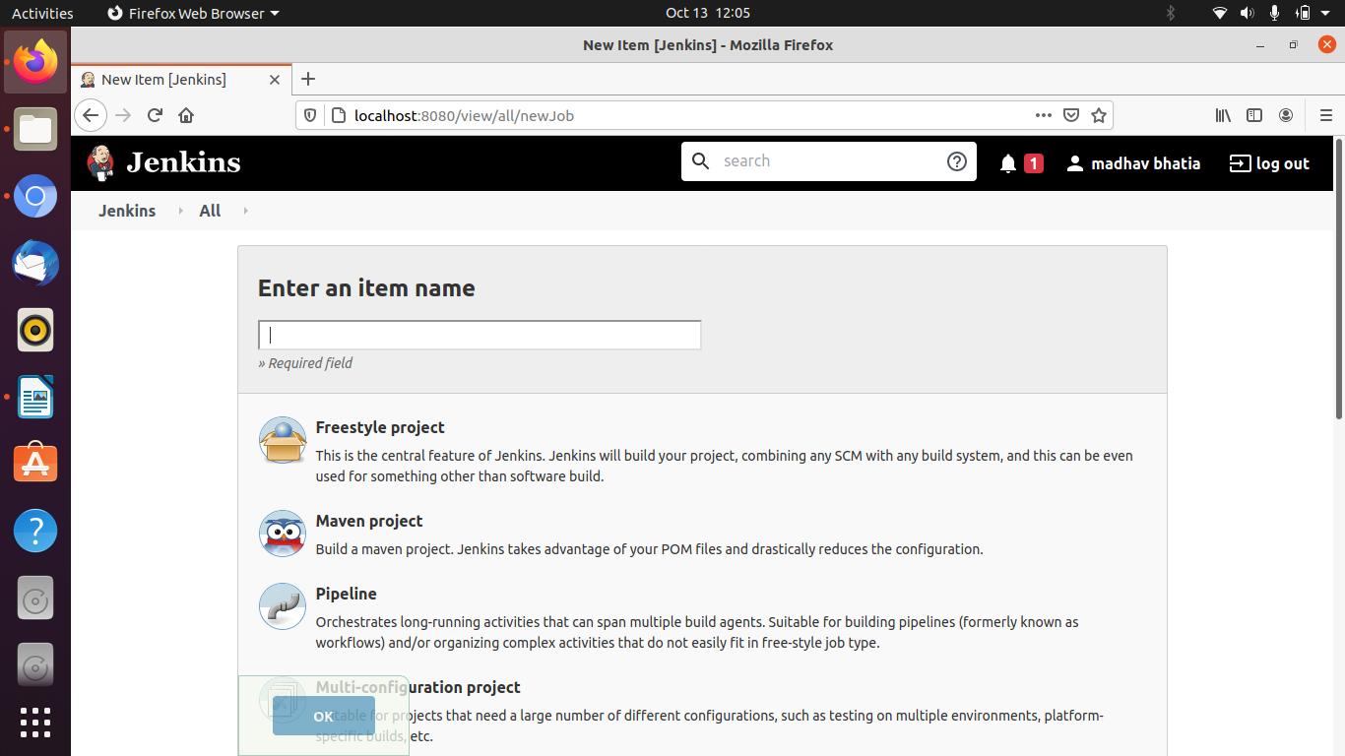

Step-3: Now make further settings. Go to source code management, click on git, and provide the URL of the GitHub repository and path of pom.xml file.

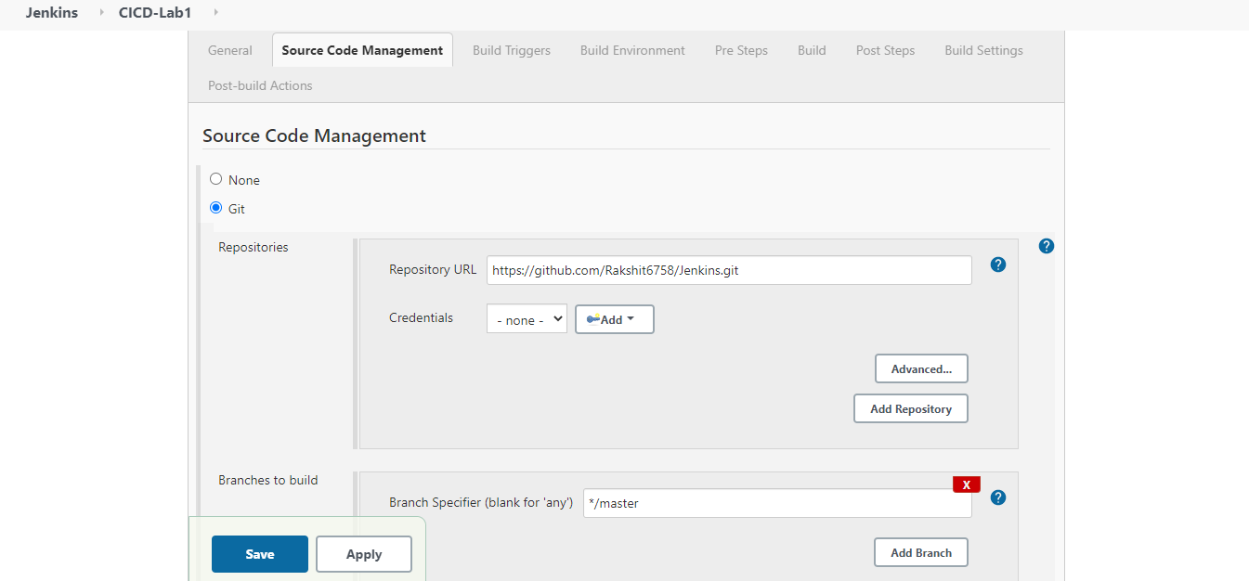

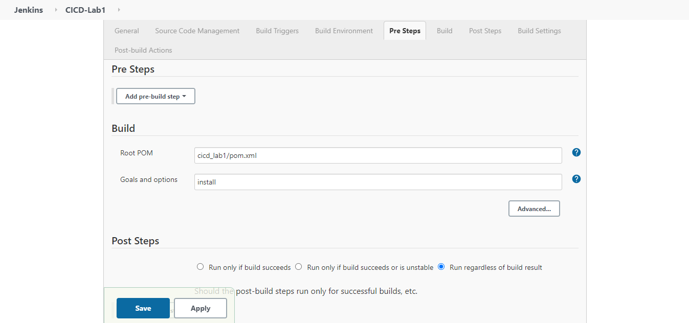66

Step-4: Click on save button and your Jenkins is integrated with GitHub and maven for this repository. Click on Build now to check the code and the changes you made.

